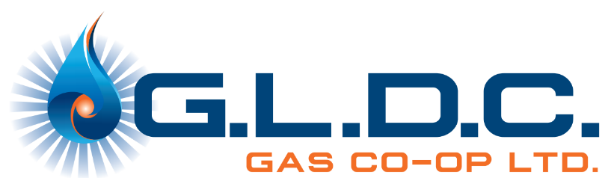

Gas Co-op Post-Secondary Scholarship Application
The GLDC Gas Co-op is proud to support local youth as they pursue their educational and career goals. Each year, we award two $1,000 scholarships to eligible students within our franchise area who are entering a recognized post-secondary or trades program.
Applicants must be a current gas customer in good standing, or the child of a current customer in good standing.
One of the two awards is presented as “The Jack Siebenga Memorial Scholarship”, honouring the lasting contributions Jack made to our co-op and community.
Full eligibility details and application information is listed below. You may visit or contact the office at 403-843-1050.

Eligibility
Applicants must:
- Be a current gas customer in good standing or child of a current gas customer in good standing within the GLDC Gas Co-op franchise area.
- Be entering their first year of a recognized post-secondary institution (university, college, or trade school).
- Demonstrate community involvement, academic commitment, and/or interest in contributing to rural development or energy-related fields (preferred but not mandatory).

Application Requirements
Applicants must submit the following:
- Completed Application Form (see below).
- Personal Statement / Essay (250–500 words) discussing yourself and outlining future goals and achievements.
- Official or Unofficial Transcript from your most recent high school year.
- Proof of Acceptance or Enrollment at a post-secondary institution (university, college, or trade school).
- One Letter of Reference (teacher, community leader, or employer).
- Community involvement, extracurricular and volunteer activities.
Applications will be reviewed based on:
- Community and volunteer involvement
- Alignment with the Co-op’s values, integrity, mission, vision and sustainability

“The Jack Siebenga Memorial Scholarship”

The following information is being collected to determine and verify your eligibility for a scholarship. To qualify, you must be a current gas customer, or the child of a customer in good standing; provide proof of enrollment in a post-secondary or trade institution; supply an official or unofficial transcript; a list of any community involvement, extracurricular/volunteer experience(s) and sign a waiver authorizing G.L.D.C. Gas Co-op to publish your name and photo if you are selected as a scholarship recipient.
Two $1,000.00 scholarships are available and may be awarded to a student only once.
One scholarship will be presented as “The Jack Siebenga Memorial Scholarship”
Application Deadline: June 30th

Scholarship Application Form

Section 1: Applicant Information
First Name: _________________________________________ Last Name: ____________________________________________
Phone Number: ____________________________________ Email: _________________________________________________
Mailing Address: ________________________________________________________________________________________________
Parent/Guardian Name(s): ____________________________________ Gas Account #: ____________________________
Section 2: Educational Information
High School Attended: ______________________________________________ Graduation Year: ________________________
Post-Secondary/Trades Institution ____________________________________________________________________________
Town/City: _______________________________________________________________________________________________________
Program: __________________________________________________________________________________________________________
Program Start Date: ______________________________ Length of program in years: _______________________________
Transcripts attached Proof of enrolment in Post-Secondary/Trade Institution attached
Section 3: Community Involvement / Extracurricular Activities and Volunteer
(Briefly describe your involvement in clubs, volunteering, employment, or community service)
_____________________________________________________________________________________________________________________
_____________________________________________________________________________________________________________________
_____________________________________________________________________________________________________________________
_____________________________________________________________________________________________________________________
Applicant Declaration:
I declare that the information provided in this application is true and complete. I understand that false statements may result in disqualification.
Signature: _________________________________________ Date: ________________________________________
Submission Instructions
Please submit your completed application package by June 30th.
You may submit your application by:
1) mail
GLDC Gas Co-op Ltd.
Attn: General Manager
Box 1909
Rimbey, AB T0C 2J0
2) drop off at our office located at 4402 – 54 Avenue, Rimbey or;
3) email your application to admin@gldcgas.com

Attachments:
- Application
- Personal statement / essay of 250 – 500 words outlining your future goals and achievements.
- Related transcripts
- Proof of enrollment
- Reference letter

Award Notification
Successful applicants will be notified by August 31st

Questions:
Phone: 403-843-1050
Email: admin@gldcgas.com

